**SQL Queries**

**1.Total Customers**

select COUNT(distinct customer_id) as Total_Customers

from Customers;

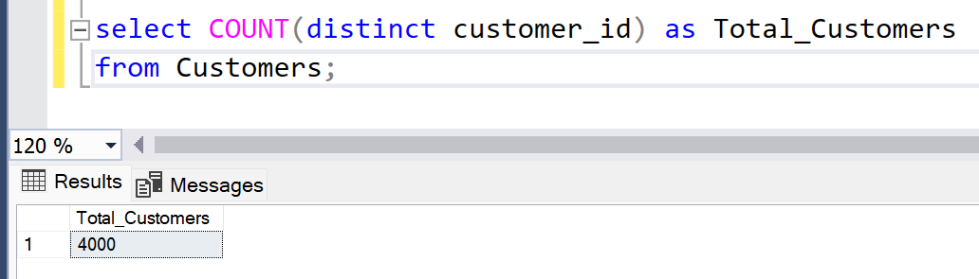

**2.**